Technical Journal of Advanced Mobility
―For MS-Word users―

Author Name 1 ^{*1}，Author Name 2 ^{*2}
Affiliation 1 ^{*1}
Affiliation 2 ^{*2}

This template is a basic format for creating a paper of the Technical Journal of Advanced Mobility (TJAM) using MS-Word. The abstract should be around 300 words. It should summarize the content of the paper by giving a clear indication of the objective, scope, and the results so that readers may determine whether the full text will be of particular interest.

Keyword: Unmanned Aerial System, UTM, UAM, Drone, Mobility

1．Introduction
Please submit your manuscript with the editable MS-Word file and PDF file by e-mail to the secretariat. The submitted manuscript will be reviewed by the editorial board. The selected manuscript will be edited by the publisher. The author can confirm the details during proofreading with the publisher directly. Please thoroughly refine and check the manuscript before submission since the replacement of the content or author after submitting the manuscript cannot be accepted.

2．Page size
The page should be formatted in a one-column format on A4 size paper (210 x 297 mm). Top and bottom margins should be 30 mm. Side margins should be 25 mm.

3．Page style
3-1 Style
This template has a basic format for one-column using the text type showing in the below table. The manuscript will be typeset by the publisher eventually.

3-2 Figure and Tables
Figures and Tables should be inserted at the appropriate section in your text. Each figure should have a figure caption at the bottom of the figure in bold. The caption of a table should appear at the top of the table in bold. References should appear in the text as numbers in brackets, such as [1] or [1], [2] and be listed at the end of the article according to the sequence they appear in the text.

3-3 Equations
All equations should be typed, centered. They should be numbered consecutively in parentheses at the right-hand margin, in line with the last line of the equation.
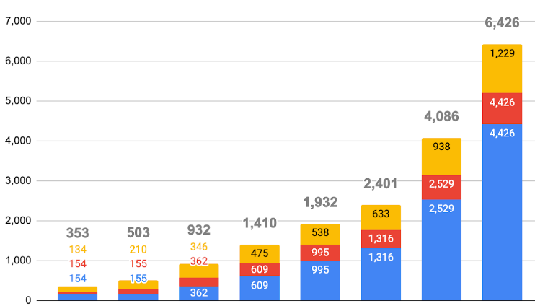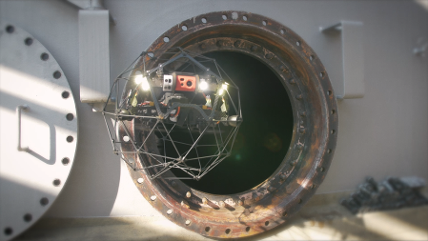
Fig.1 Market size of Japanese Drone Industry Fig. 2 Inspection Drone

Table. 1 Text type
Contents | Font | Size
Title | Arial, Bold, be centered | 22pt
Sub-Title | Arial, Bold, be centered | 18pt
Authors’ Names | Times New Roman, be centered | 12pt
Authors’ Affiliations | Times New Roman | 10pt
Abstract, Keyword | Times New Roman | 10pt
Heading | Arial | 11pt
Body of the paper | Times New Roman | 11pt
Figure and Table caption | Times New Roman, be centered | 9pt
References, Biography | Times New Roman | 8pt
Received: March 10, 2021
Accepted: May 10, 2021

References
［1］ Kakuya, I., Naohisa, H., and Kiyoshi, K.: Aerial Robotic System for Transportation and Logistics, Journal of Mechanical Systems for Transportation and Logistics, Vol. 1, No. 1, pp.146-157, 2008.
［2］ Kakuya, I., and Osamu, M., Aerial Cargo Robot (Cargo UAV)，Journal of Robotics and Mechatronics, Vol. 26, No. 3, pp. 394‒395, 2014.
［3］ https://www.jstage.jst.go.jp/article/tjam/1/1/1_2/_article/-char/ja.

Authors
Biography
Please insert the author’s biography
With 300 words maximum.

E-mail: journal@uas-japan.org
Photo

